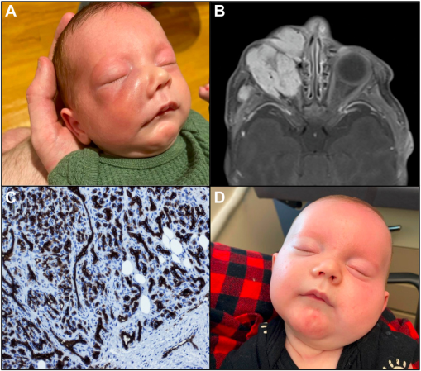

A 45-day-old boy presented with 2 weeks of worsening right-sided facial swelling . The patient did notrespond to a 7-day course of intravenous clindamycin. Physical examination revealed periorbital and maxillary swelling without erythemaor induration (A). Magnetic resonance imaging revealed a 332ecm lobulated mass in the right inferior orbit with proptosis and partialencasement of the optic nerve (B). Given concerning features on imaging, biopsy was performed, showing tightly packed capillariesorganized into lobules and endothelial cells staining for glucose transporter 1 (GLUT-1) (C). Oral propranolol was initiated with significant improvement (D). Based on the provided images and clinical description please make an ophthalmic diagnosis for this patient. And output the diagnostic conclusions only.

**Orbital infantile hemangioma.**